How to Creation an EasyChair Account & Submitting your manuscript
How to Create an EasyChair Account
1. To create an account, go to the https://easychair.org/account/signin.cgi?key=63249297.Lmfbt5ihFz4uTHOl
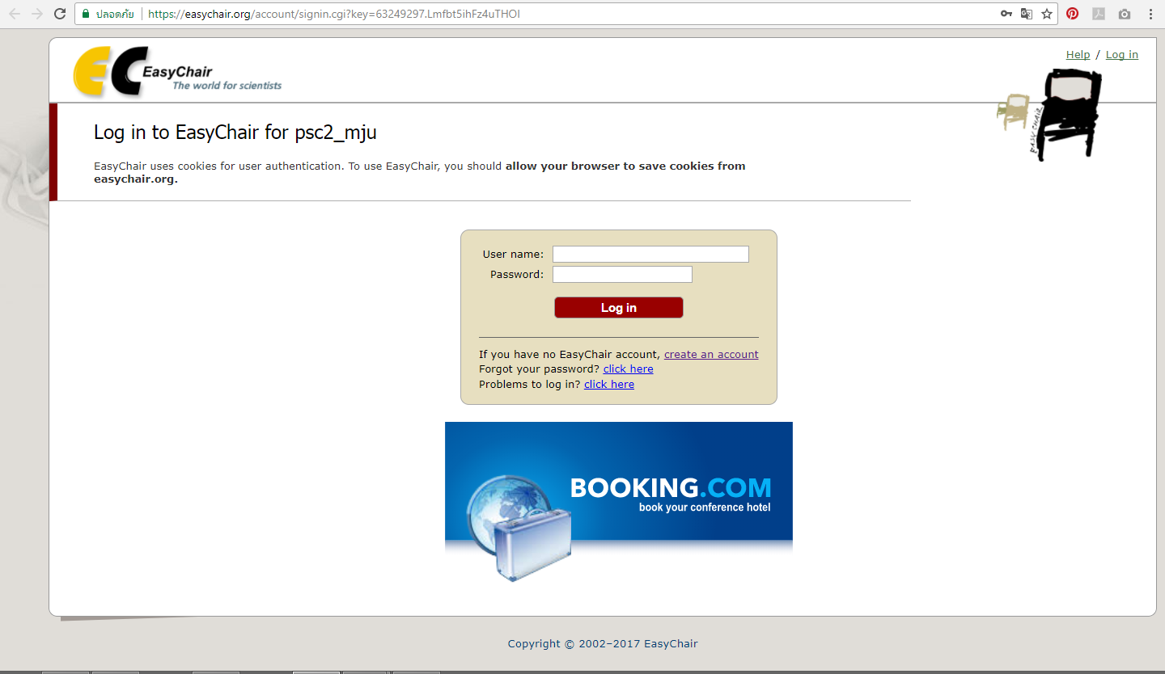

2. Click on “create an account”
3. You should type the text that you see in the image below and click on "Continue". 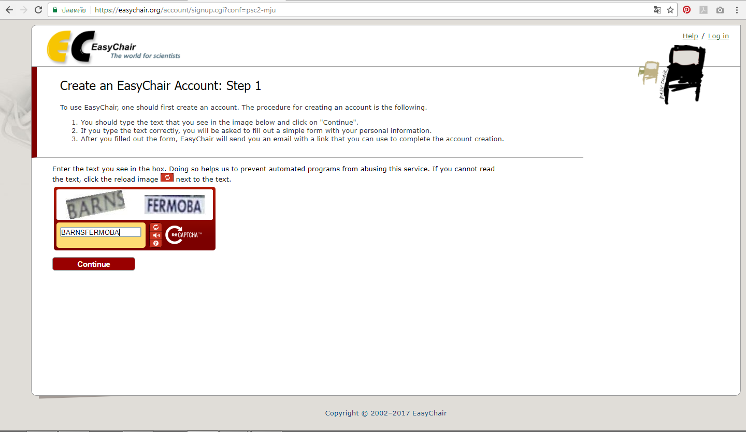

4. The next page you visit will contain this form. You will be asked to fill out a simple form with your personal information. And then Click on “Continue”
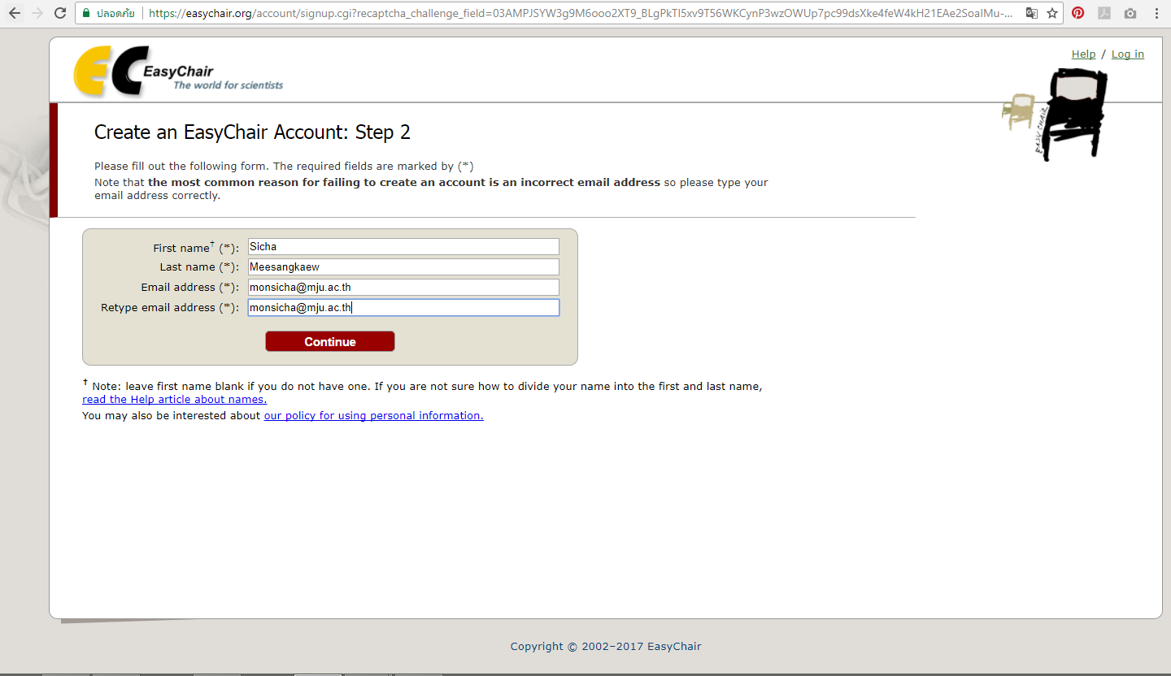

5. After you fill out the form, EasyChair will send a verification email to this email address, to make sure that you own this address and that it can receive emails from EasyChair.
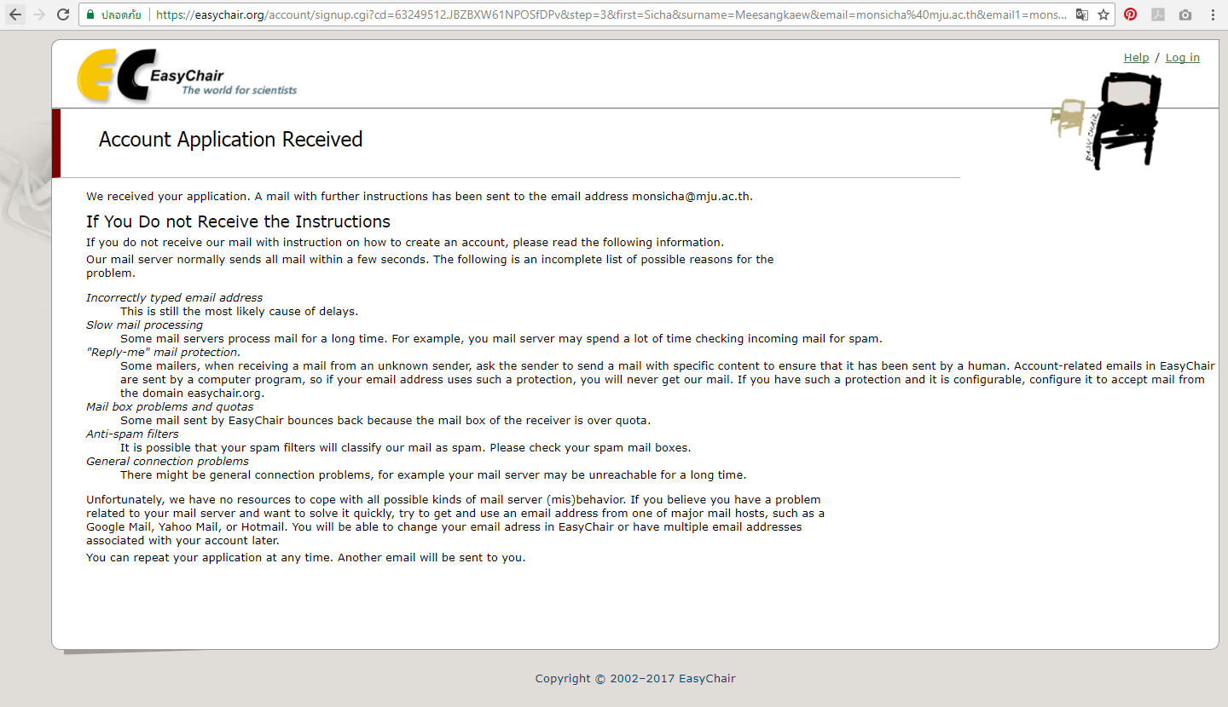

6. You will receive a confirmation email. Click on the link provided in the email to continue your registration 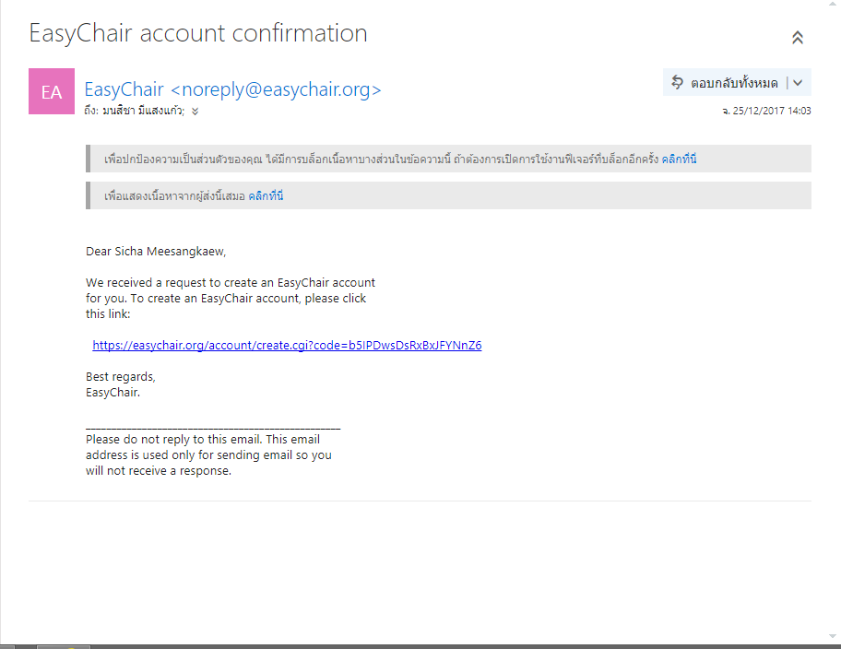
7. In most cases you receive the email, follow the link, see the form like this :
Complete your registration by providing all the required information and click on “Create my account”
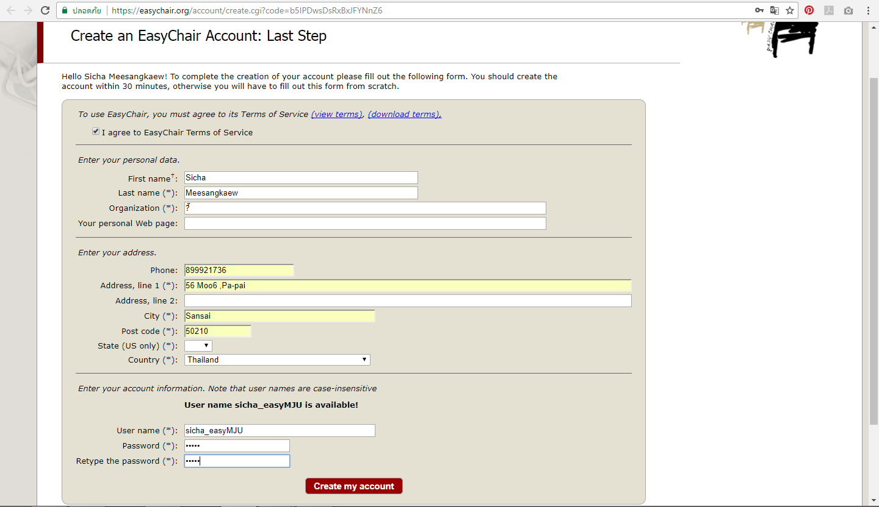

9. EasyChair will display a message that you have successfully registered your account.
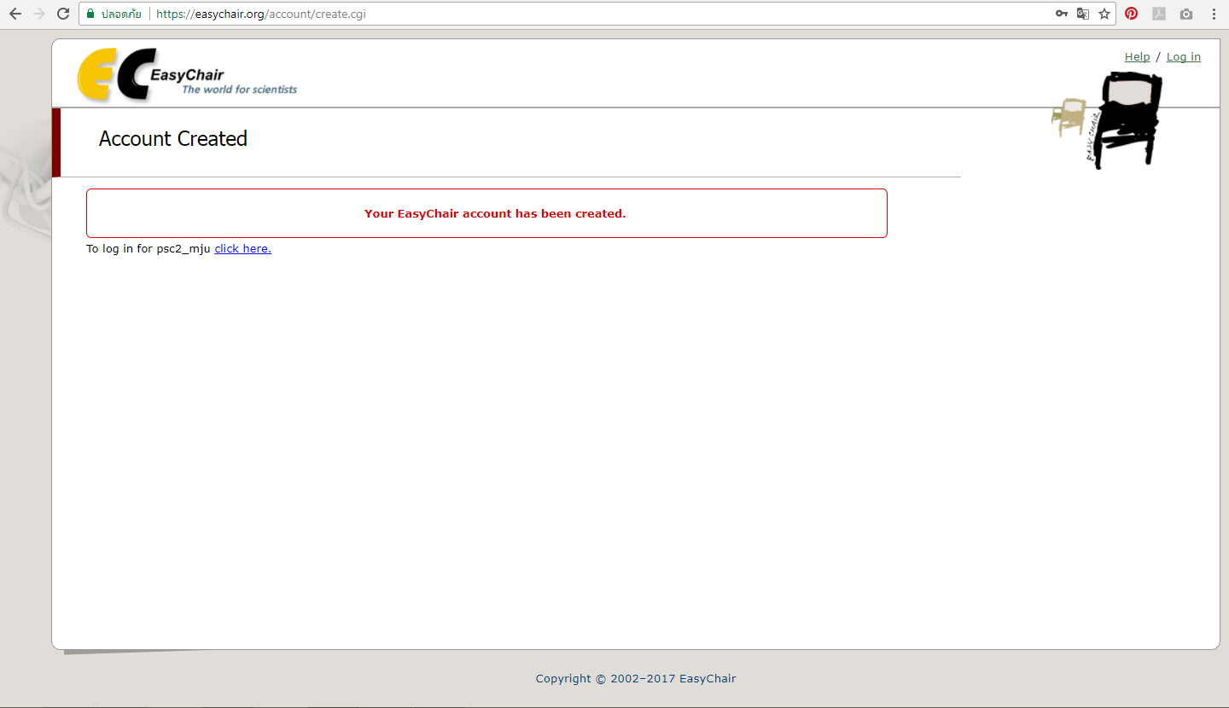

Submitting your manuscript
1. Go to website : https://easychair.org/account/signin.cgi?key=63249297.Lmfbt5ihFz4uTHOl
2. Logging in to Your Account. Start by entering your username and password and then click on “Log in”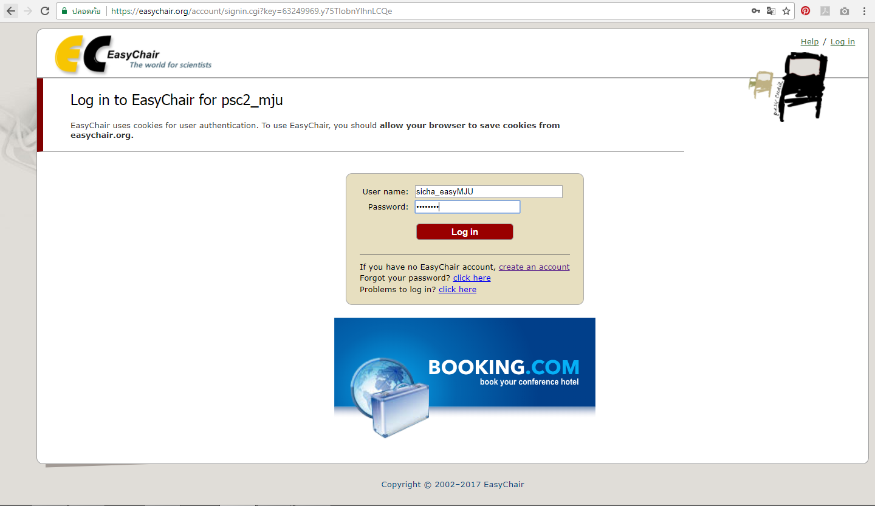
3. Click on “enter as an author”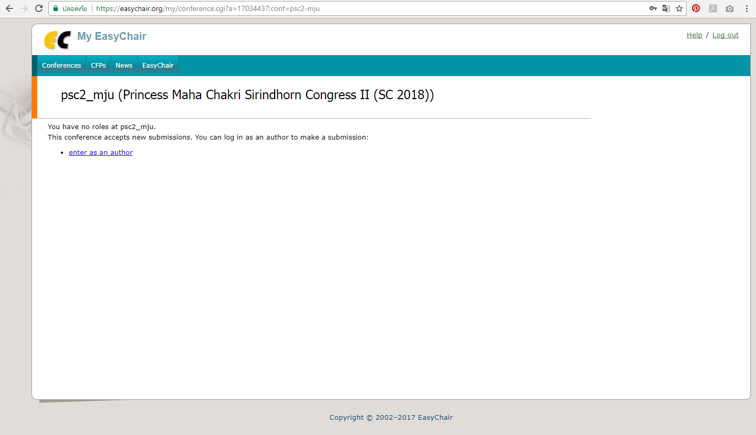

4.From the main menu bar (on the top) choose "New Submission".
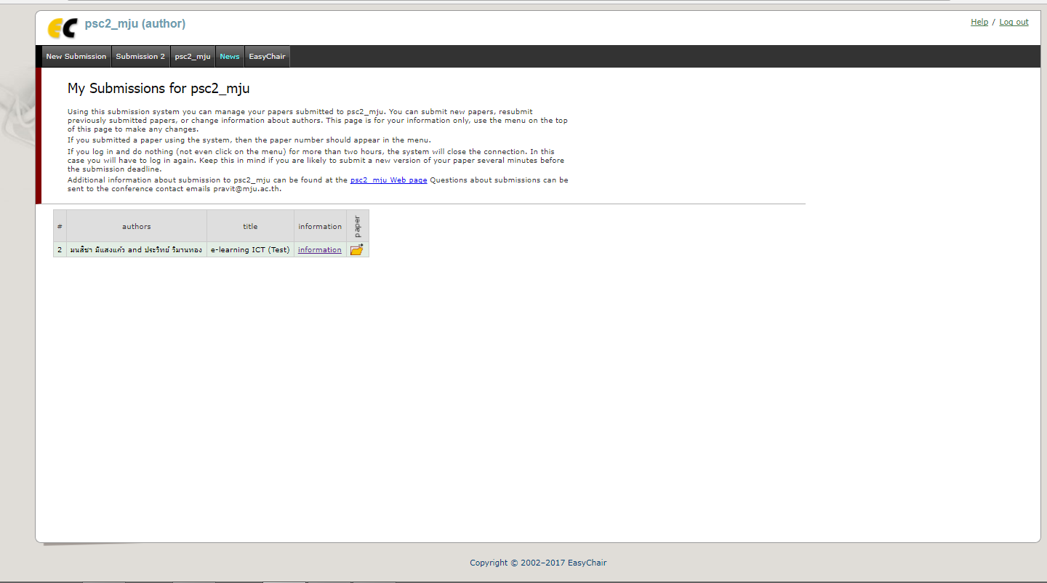
4. Follow the instructions and fill in all the requested information.
4.1 Author Information : For filling in author /authors information, you may speed up the process by clicking on “click here to add yourself”. Each author marked as a corresponding author will receive email messages from the system about this submission. There must be at least one corresponding author. 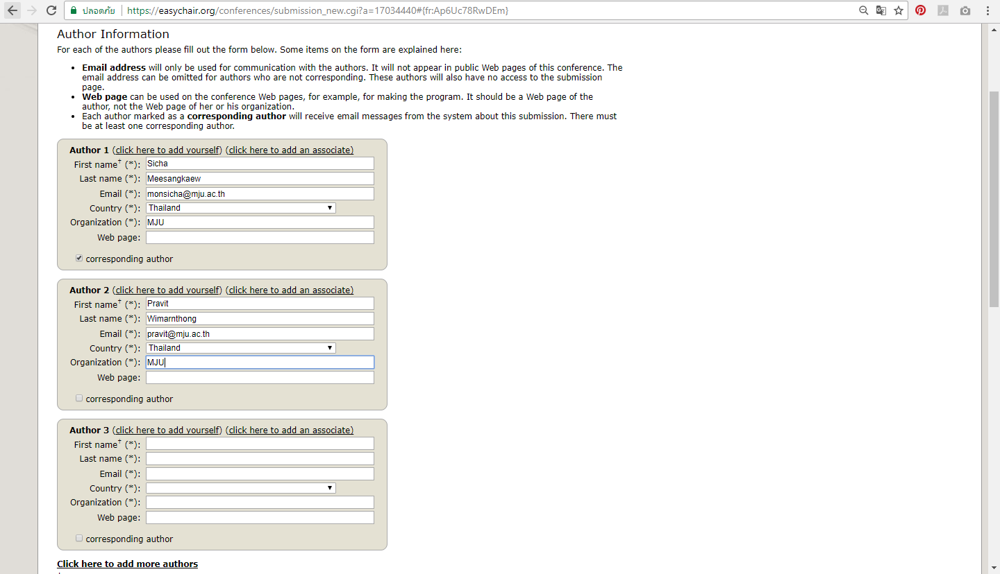

4.2 Title and Abstract : Enter the title of your paper. The title and the abstract should be entered as plain text, they should not contain HTML elements.
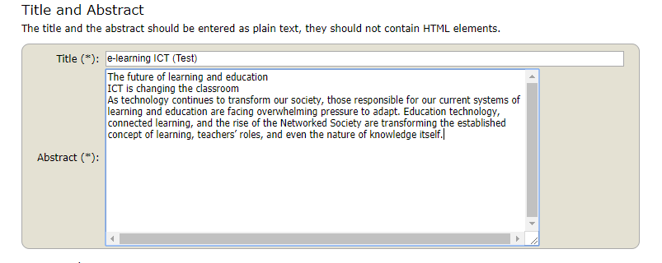
4.3 Keywords : Type a list of keywords , one per line to characterize your submission. You should specify at least three keywords.
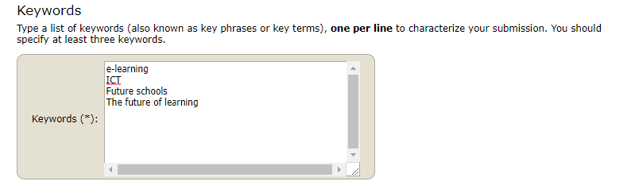
4.4 Uploads : Upload your paper in PDF format (and update your paper later in word 2010)
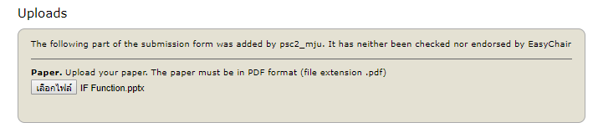
4.5 If you filled out the form, press the “Submit” button.
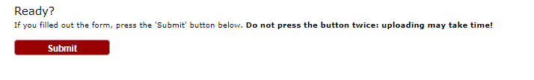

Now you will see basic information about your submission. You can get back to the page with your submission details anytime by clicking on “My Submission” located in the top-left corner of the main menu bar. 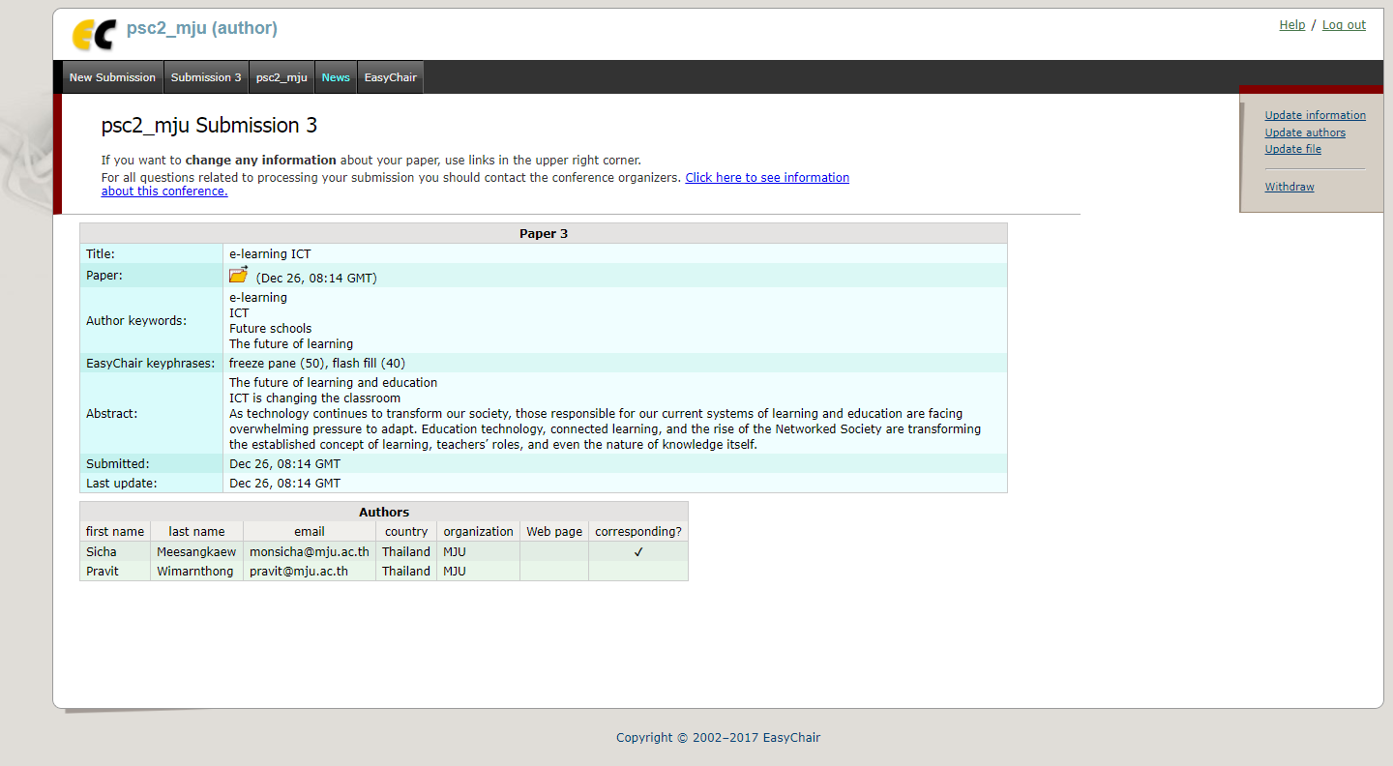
Updating your submission
Click on your Submission,Then use the links on the right side to make changes .

-----------------------------------------------------------------------------------

